|  |  |  |
| --- | --- | --- |
| Item | Number | Source |
| Pine Wood | .29 kg CO2 eq/ kg | Database |
| Primary Glass | .91 kg CO2 eq/ kg | ICE |
| Weight of glass per square foot | 5.64 lbs | [link](http://glassservicesinc.com/cs/Satellite?blobkey=id&blobwhere=1301464014227&blobheader=application%2Fpdf&blobheadername1=Content-Disposition&blobheadervalue1=inline%3B+filename%3Dglass-services-glass-knowledge.pdf&blobcol=urldocument&blobtable=UXDocument&moddate=2012-12-13%2009:16:56) |
| average weight of wood per cubic foot | 45 lbs | [link](http://www.wood-database.com/wood-articles/average-dried-weight/) |
| aluminum weight | 9.16 kg CO2 eq/ kg | http://www.tandt-materials.com/LinkClick.aspx?fileticket=DL1z0xk7U3w= |

Calculations:

Size of whole bottom of sliding door (both panels): 96”

Size of height of sliding door: 84”

Height of lower wood frame up until the glass: 11”

Height of side wood frame until the glass: 5.875”

Depth of door: 2.0625”

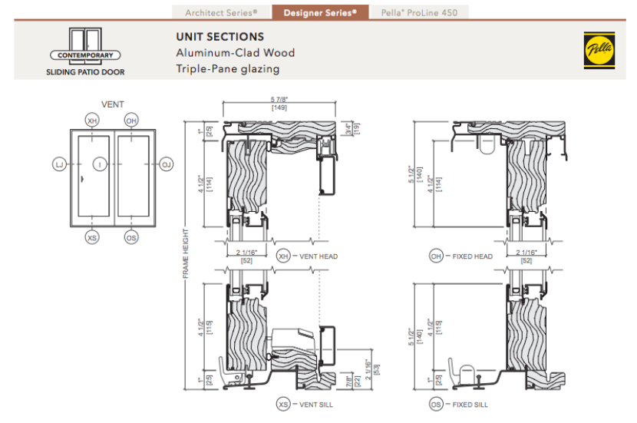

Solving for Glass in one panel:

Subtract out wood

new bottom length: 48”

new height: 84”

subtract out the wooden frames:

48-5.875-5.875 = 36.25”

84-11-11=62”

Then subtract the lines through the glass which have width of 1 inch.

from the height:

there are five in the horizontal direction

62-(5*1”) = 57”

36.25-(3*1”) = 33.25”

This leaves just the glass.

Amount of glass:

57X33.25 = 1895.25 square inches of glass

convert to square feet: 13.16 square feet

½ an inch thick glass (which is an assumption) weighs 6.54 pounds per square foot (link above) so:

13.16 X 6.54 = 86.06 lbs

convert to kg:

39.04 kg

there are .91 kg CO2 eq/ kg in 1 kg.

39.04 X .91 = 35.53 kg CO2 eq/ kg carbon in one panel of glass in this door

35.53 kg CO2 eq/ kg X 2 panels = **71.06 kg CO2 eq/ kg in the glass**.

Amount of wood:

2.0625 X 11 X 48 = 1089 cubic inches = .63 cubic feet

.63 X 4 for 4 of these bottom blocks of wood in both panels = 2.52 cubic feet

5.875 X 2.065 X 62 = 751.27 cubic inches = .435 feet cubed

.435 X 4 for all the side blocks of wood in both panels = 1.74

Then the wooden lines through the glass:

1”X1”X36.25” = 36.25”

35.25” X 5(horizontal bars) = 181.25 cubic inches = .105 cubic feet

.105 X2 for both panels = .21 cubic feet

1”X1”X62” = 62”

62”X3 (vertical bars) = 186 cubic inches = .1076 cubic feet

.1076 X 2 for both panels = .2152 cubic feet

add up all the wood:

1.74 + 2.52 + .21 + .2152 = 4.6852 cubic feet of wood

4.6852 X 45 lbs = 210.834 lbs = 95.633 kg.

95.633 kg X .29 kg CO2 eq/ kg = **27.73 kg CO2 eq/ kg in the wood**

Aluminum handle/exterior aluminum stuff:

*rough estimate:

560 (total weight) - 210.834 lbs (weight of wood) - 86.06 lbs(weight of glass) = 263.11 lbs of aluminum material life (like the locks, the handle, exterior aluminum finish)

convert to kg: 119.345 kg

119.345 kg X 9.16 kg CO2 eq/ kg = **1093.20 kg CO2 eq/ kg in the aluminum in the door**

**ADD UP:**

**1093.20 kg CO2 eq/ kg in the aluminum in the door + 71.06 kg CO2 eq/ kg in the glass**.

**+27.73 kg CO2 eq/ kg in the wood =**

**1191.99 kg CO2 eq/ kg in the Pella door.**

Note: This does not account for actual production of the door, nor transportation.